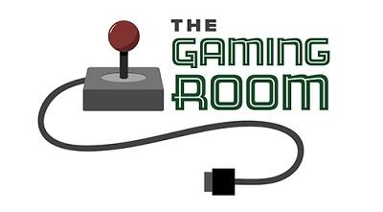
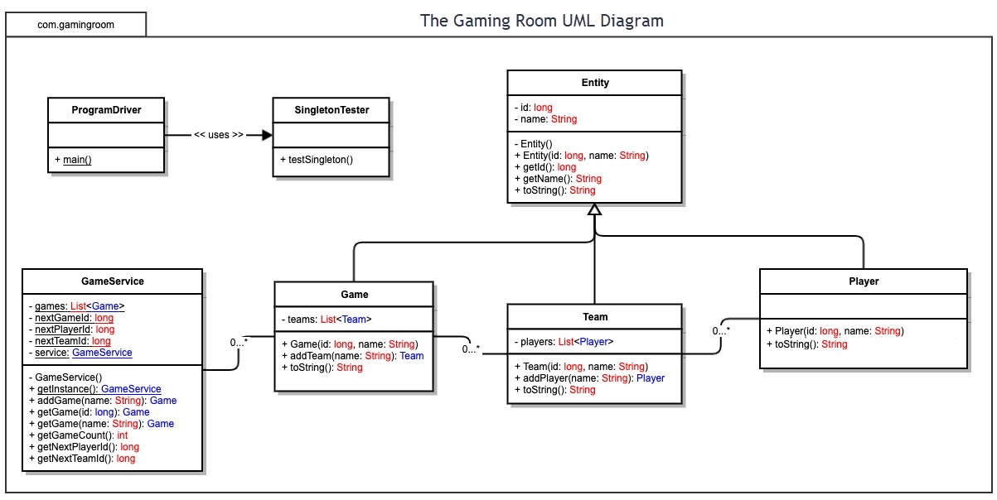

Draw It or Lose It

CS 230 Project Software Design Template
Version 1.0

Table of Contents

1.CS 230 Project Software Design Template 1
Table of Contents 2
Document Revision History 2
Executive Summary 3
Requirements 3
Design Constraints 3
System Architecture View 3
Domain Model 3
Evaluation 4
Recommendations 5
2.Operating Platform: <Recommend an appropriate operating platform that will allow The Gaming Room to expand Draw It or Lose It to other computing environments.> 5
3.Operating Systems Architectures: <Describe the details of the chosen operating platform architectures.> 5
4.Storage Management: <Identify an appropriate storage management system to be used with the recommended operating platform.> 5
5.Memory Management: <Explain how the recommended operating platform uses memory management techniques for the Draw It or Lose It software.> 5
6.Distributed Systems and Networks: <Knowing that the client would like Draw It or Lose It to communicate between various platforms, explain how this may be accomplished with distributed software and the network that connects the devices. Consider the dependencies between the components within the distributed systems and networks (connectivity, outages, and so on).> 5
7.Security: <Security is a must-have for the client. Explain how to protect user information on and between various platforms. Consider the user protection and security capabilities of the recommended operating platform.> 5

Document Revision History

Version | Date | Author | Comments
1.0 | 07/10/23 | Xavier Paquette | Initial document
2 | 07/26/23 | Xavier Paquette | Refined table in 'Evaluation'
3 | 08/11/23 | Xavier Paquette | Completed “Reccomendation” Section

Instructions
Fill in all bracketed information on page one (the cover page), in the Document Revision History table, and below each header. Under each header, remove the bracketed prompt and write your own paragraph response covering the indicated information.

Executive Summary

Draw It or Lose It is a web-based game where teams look at stock images to guess the word that is being shown. Each round lasts one minute, with the stock images all being shown at the 30-second mark. If the current active teams does not correctly guess the word within the time limit, the other teams may submit one guess each in 15 seconds.

Requirements

< Please note: While this section is not being assessed, it will support your outline of the design constraints below. In your summary, identify each of the client’s business and technical requirements in a clear and concise manner.>

Design Constraints

<Identify the design constraints for developing the game application in a web-based distributed environment and explain the implications of the design constraints on application development.>

Developing for different browsers can be challenging, as each operating system can use several different browsers. Especially mobile, as instead of using an UI with a landscape view, Mobile typically uses a portrait view. I will have to develop the app with landscape and portrait Uis in mind, and possibly develop different versions of the app for each browser that will be used.

System Architecture View

Please note: There is nothing required here for these projects, but this section serves as a reminder that describing the system and subsystem architecture present in the application, including physical components or tiers, may be required for other projects. A logical topology of the communication and storage aspects is also necessary to understand the overall architecture and should be provided.

Domain Model

<Describe the UML class diagram provided below. Explain how the classes relate to each other. Identify any object-oriented programming principles that are demonstrated in the diagram and how they are used to fulfill the software requirements efficiently.>

ProgramDriver uses SingletonTester. Game, Team, and Player inherit Entity (Obviously, this is a demonstration of the OOP principle Inheritance). GameService has 0-to-many Games, Game has has 0-to-many Teams, Team has 0-to-many Players.

Abstraction is demonstrated by Entity having a private id variable that is not able to be modified after creation but can be read by using getId(). Encapsulation is displayed by multiple functions being grouped under the GameService class. Polymorphism is demonstrated by there being many players going by different names.

Evaluation

Using your experience to evaluate the characteristics, advantages, and weaknesses of each operating platform (Linux, Mac, and Windows) as well as mobile devices, consider the requirements outlined below and articulate your findings for each. As you complete the table, keep in mind your client’s requirements and look at the situation holistically, as it all has to work together.

In each cell, remove the bracketed prompt and write your own paragraph response covering the indicated information.

Development Requirements | Mac | Linux | Windows | Mobile Devices
Server Side | User-friendly interface, stable and secure environment. Software requires a license. Server-based deployment possible. | Open-source software, highly customisable, secure, reliable, steep learning curve. Server-based deployment possible. | User-friendly interface, broad compatibility with software and hardware, not as secure as Mac or Linux. Software requires a license. Server-based deployment possible. | Limitations in system resources. Difficult to setup a server. No license required. No server-based deployment.
Client Side | By designing a web-based app for PCs, it becomes accessible and usable on any PC with a web browser. | By designing a web-based app for PCs, it becomes accessible and usable on any PC with a web browser. | By designing a web-based app for PCs, it becomes accessible and usable on any PC with a web browser. | If an website is already made, it should work on mobile devices, but it may not look good. Extra development may be needed to make an UI exclusive for mobile devices.
Development Tools | Visual Studio Code, Atom, or Sublime Text are used as IDEs. These IDEs are free or low cost. One team can work on the UI for Mac, Linux, and Windows, as their web browsers are functionally identical.  For all 4 Operating Systems, the web programming languages used are JavaScript, HTML, CSS, and backend languages like Python, Ruby, or PHP. | Popular IDEs for Linux development include Visual Studio Code, JetBrains' IntelliJ IDEA, Eclipse, and Atom. These IDEs are free or low cost. One team can work on the UI for Mac, Linux, and Windows, as their web browsers are functionally identical. | Developers on Windows often use IDEs like Visual Studio Code, Visual Studio, Atom, or Sublime Text for web development. These IDEs are free or low cost. One team can work on the UI for Mac, Linux, and Windows, as their web browsers are functionally identical. | One IDE on Android would be AIDE. One on iOS would be Koder. Both of these are free. Developing exclusively for mobile may require an additional software team.

Recommendations

Analyze the characteristics of and techniques specific to various systems architectures and make a recommendation to The Gaming Room. Specifically, address the following:

- Operating Platform: <Recommend an appropriate operating platform that will allow The Gaming Room to expand Draw It or Lose It to other computing environments.>

I highly recommend Linux.

- Operating Systems Architectures: <Describe the details of the chosen operating platform architectures.>

Linux is highly customizable, making it secure and fast. This comes at a trade-off that the terminal-based operating system can be daunting for new users. Thankfully, there are many guides on the internet to help newcomers through the process.

- Storage Management: <Identify an appropriate storage management system to be used with the recommended operating platform.>
For efficient management of user login information, especially considering a potentially large user base, storing such data in memory won't be feasible. Effective storage management becomes vital. An approach like IBM's indexed sequential-access method proves valuable here. It involves searching a file for a primary index, then retrieving the corresponding secondary index. In our scenario, utilizing the username as the primary index and storing all other details as secondary information could be a strategic implementation.

- Memory Management: <Explain how the recommended operating platform uses memory management techniques for the Draw It or Lose It software.>

Efficient server operation heavily relies on effective memory management. Among the key memory-consuming entities, individual game instances stand out. Managing their lifecycle becomes vital, necessitating the removal of inactive instances, such as at the game's conclusion or when no players remain online. This practice ensures optimal memory utilization and overall server efficiency.

- Distributed Systems and Networks: <Knowing that the client would like Draw It or Lose It to communicate between various platforms, explain how this may be accomplished with distributed software and the network that connects the devices. Consider the dependencies between the components within the distributed systems and networks (connectivity, outages, and so on).>

Players will interact with the server to engage in gameplay, serving as the sole conduit for player-to-player communication within the game. Given that each operating system employs a web browser for communication, utilizing a consistent Javascript codebase across devices seems feasible. While connectivity via web browsers is typically smooth, it's crucial to account for potential variations in individual users' connections, ensuring a seamless experience for all players involved.

- Security: <Security is a must-have for the client. Explain how to protect user information on and between various platforms. Consider the user protection and security capabilities of the recommended operating platform.>

Linux is a well-known and advanced operating system for hosting servers. It's highly secure, with strong protection measures in place. Its security features include controlling who can access what and using powerful tools like firewalls and encryption. Many experts work on making Linux even safer, so it's great for keeping important information safe on servers.

